**Learning Outcomes**

1. Google plus sign using OAuth

**Screenshots**

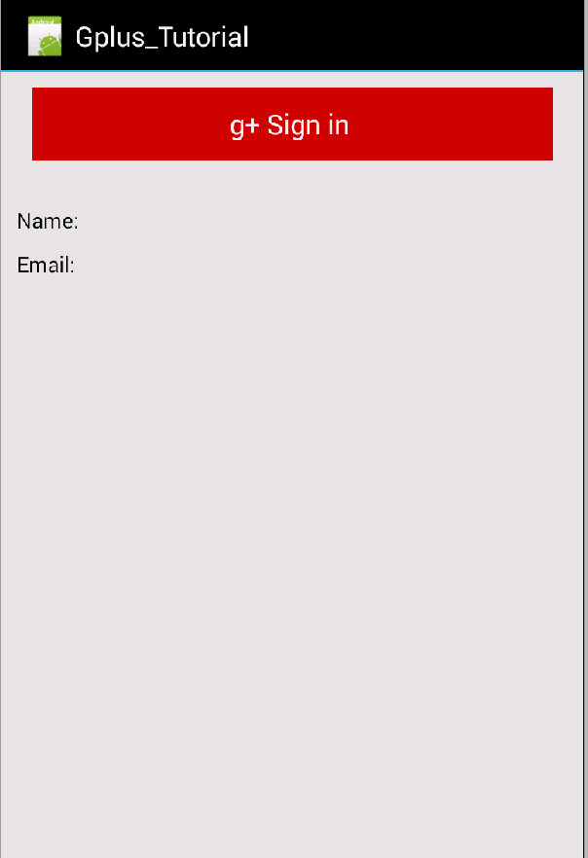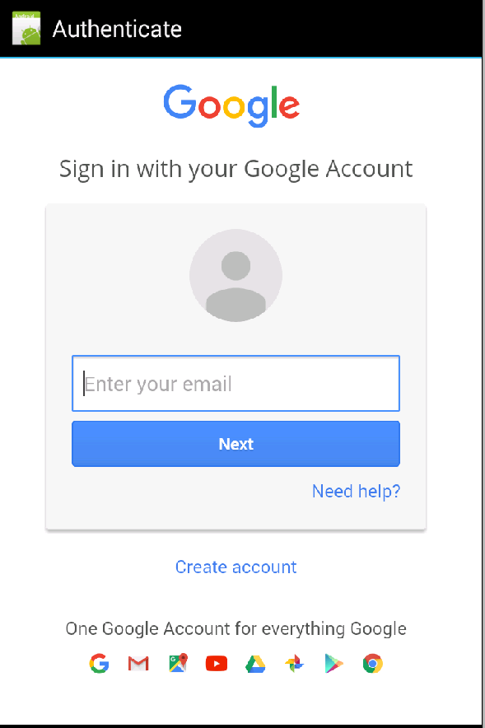

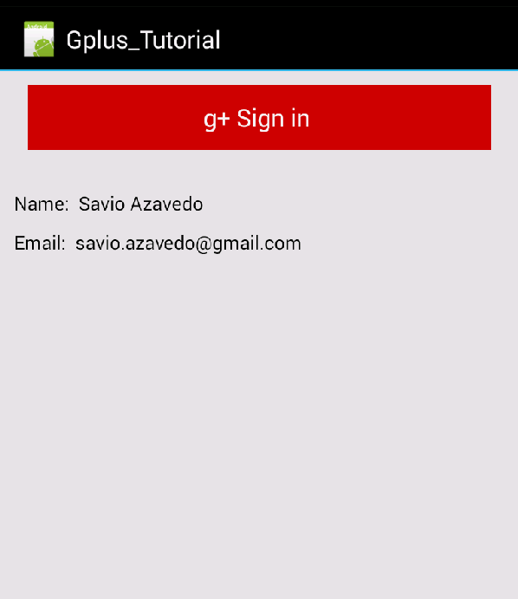

1. Start a new project

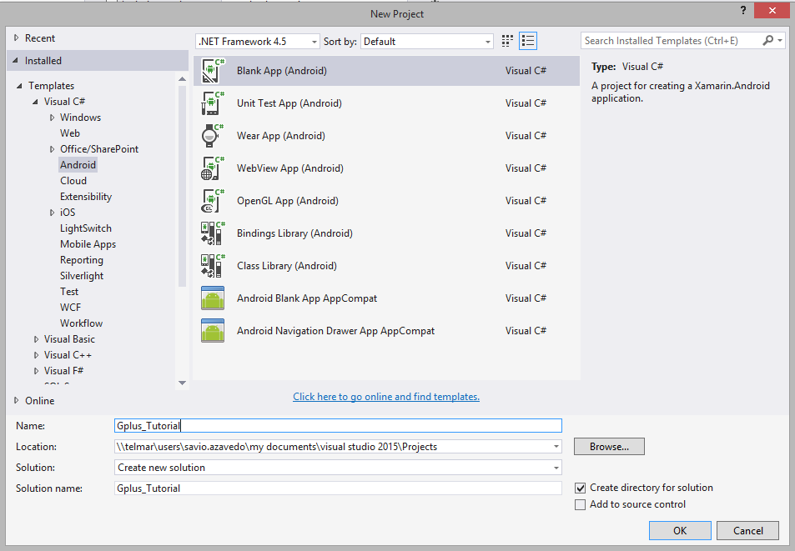

1. Add Google play services from the Component Store in Xamarin Studio

Or through Nuget package manager if using Visual Studio.

1. Set proper minimum and target android levels

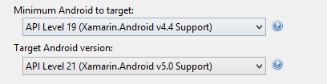

Go to

<https://console.developers.google.com>

Login with your Gmail account

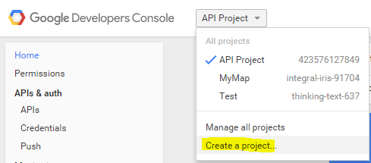

Name it

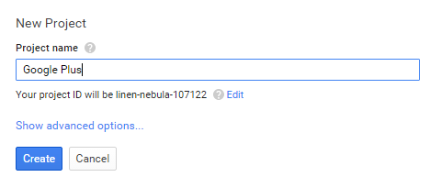

Click on API on the left hand side and then select Google+ API

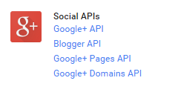

Click on Enable API

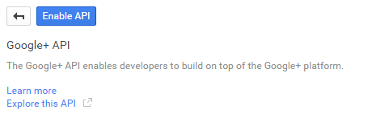

Click on Add credentials and click on Oauth2.0 client ID

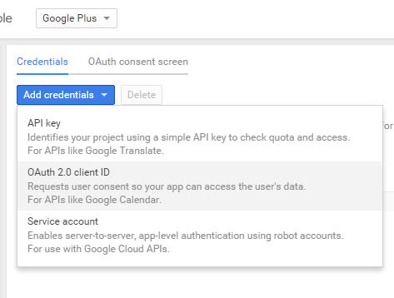

Select Web Application

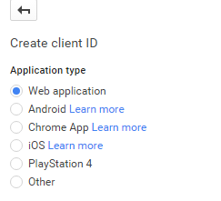

Put in the redirect URI as shown below

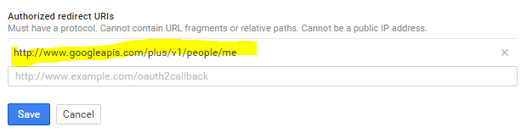

Click Create or save

In your project solution add the component Xamarin.Auth (or via Nuget packages)



Add JSON.net via the component store or Nuget



MainActivity.xaml

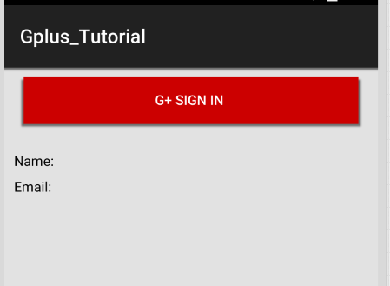

<?xml version="1.0" encoding="utf-8"?>

<LinearLayout xmlns:android="http://schemas.android.com/apk/res/android"

android:orientation="vertical"

android:layout_width="fill_parent"

android:layout_height="fill_parent"

android:background="#E2E2E2">

<Button

android:id="@+id/sign_in_button"

android:layout_width="match_parent"

android:layout_height="wrap_content"

android:text="g+ Sign in "

android:layout_marginTop="10dp"

android:layout_marginLeft="20dp"

android:layout_marginRight="20dp"

android:layout_marginBottom="30dp"

android:background="@android:color/holo_red_dark" />

<TextView

android:id="@+id/txtName"

android:layout_height="wrap_content"

android:layout_width="match_parent"

android:textColor="#000"

android:text="Name: "

android:layout_marginLeft="10dp"

android:layout_marginRight="10dp"

android:layout_marginBottom="10dp" />

<TextView

android:id="@+id/txtEmail"

android:layout_height="wrap_content"

android:layout_width="match_parent"

android:textColor="#000"

android:text="Email: "

android:layout_marginBottom="10dp"

android:layout_marginLeft="10dp"

android:layout_marginRight="10dp" />

</LinearLayout>

Add a new class GoogleInfo.cs

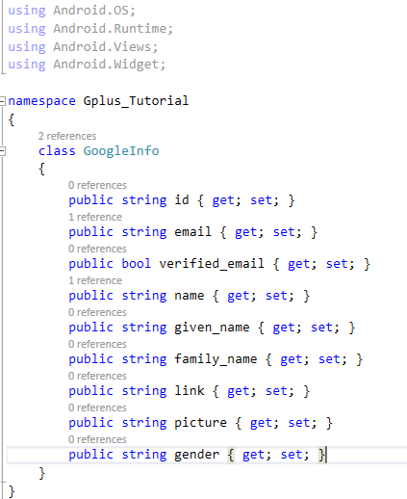

Mainactivity.cs

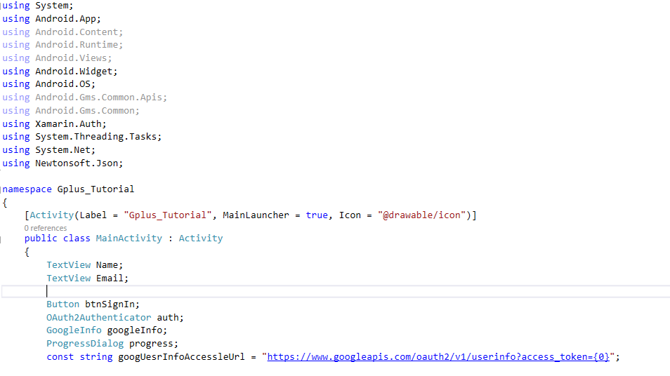

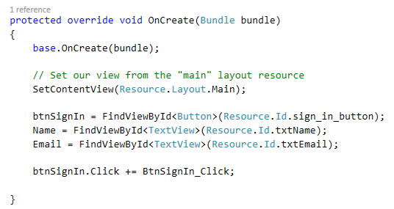

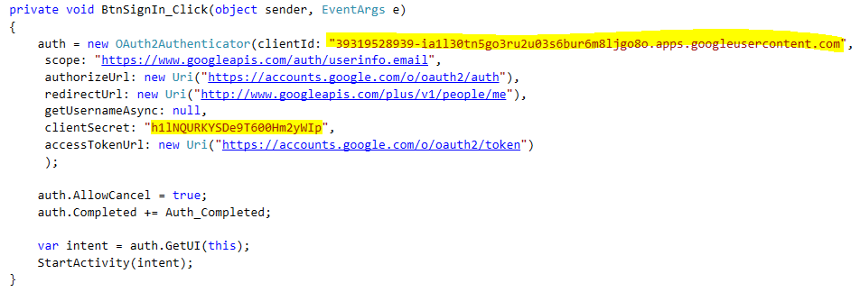

Need to put in your client ID and Secret

